Lab - 3

Understanding Breadboard Usage

1. Aim
To understand the structure and working of a breadboard and build simple electronic circuits without soldering.

2. Theory
A breadboard is a reusable platform used for prototyping electronic circuits. It allows components to be connected temporarily without soldering.
Main sections of a breadboard:
- Power Rails : Used for VCC and GND connections
- Terminal Strips : Used for placing components
- Center Gap : Separates two halves for IC placement
Advantages:
- Reusable
- Easy circuit modification
- Fast prototyping
Breadboards are widely used with microcontrollers such as Arduino Uno and ESP32.

3. Apparatus / Requirements
- Breadboard
- LED
- 220Ω resistor
- Jumper wires
- Battery or Arduino board

4. Circuit Diagram
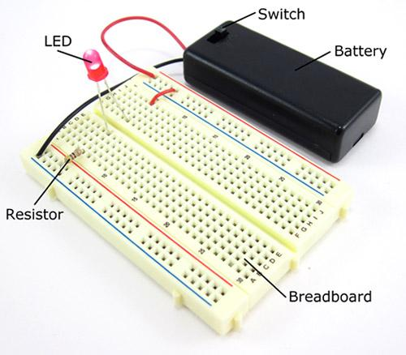

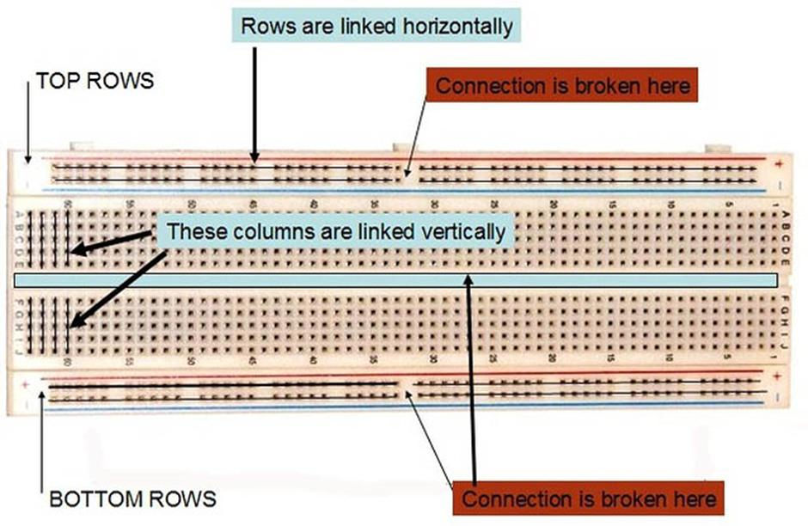

5

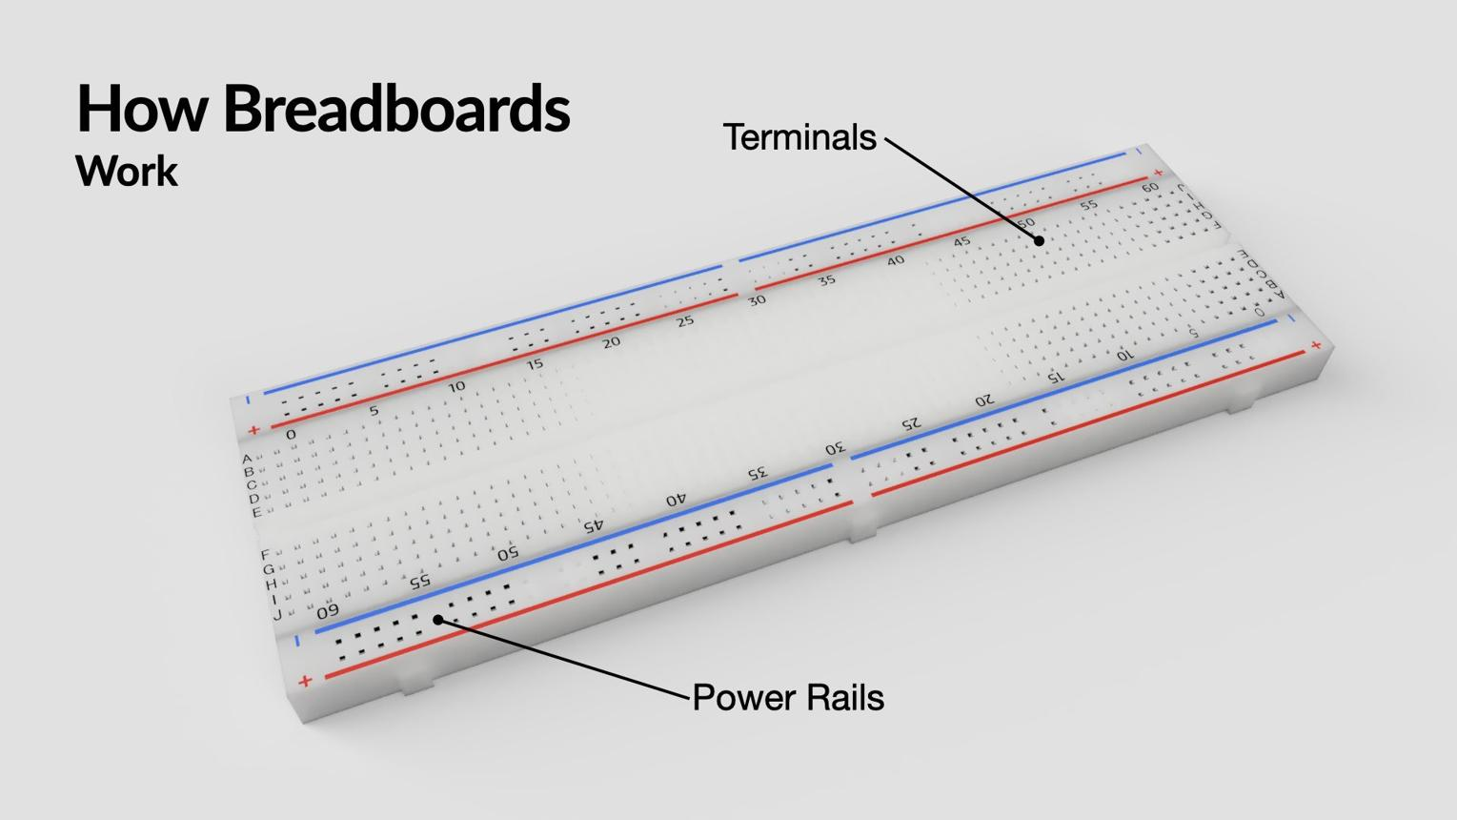

5. Procedure (Steps)
- Identify breadboard rows and columns
- Connect power rails to VCC and GND
- Insert LED and resistor into breadboard
- Use jumper wires for connections
- Verify continuity and connections
- Power the circuit and observe output

6. Observations / Readings
- Breadboard connections worked without soldering
- LED glowed successfully
- Proper row-column connectivity observed

7. Result
The breadboard structure and connection methodology were successfully studied and implemented.

